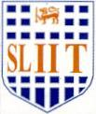
Image Understanding and Processing (OpenCv - Python)

Practical Examination – D
Year 4 Semester 1, 2021

Apply following averaging filter to the input image (A) and obtain the output image (B). Then apply Unsharp Masking to generate the output (C). Use the below code to generate the output images.

1 | 1 | 1 | 1 | 1
1 | 1 | 1 | 1 | 1
1 | 1 | 1 | 1 | 1
1 | 1 | 1 | 1 | 1
1 | 1 | 1 | 1 | 1

1/25

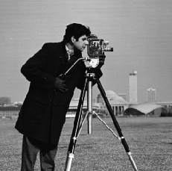
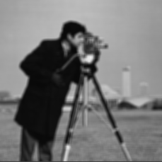
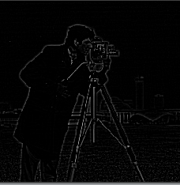
Input Image (A)
Output Image (B)
Output Image (C)

